*Monday*

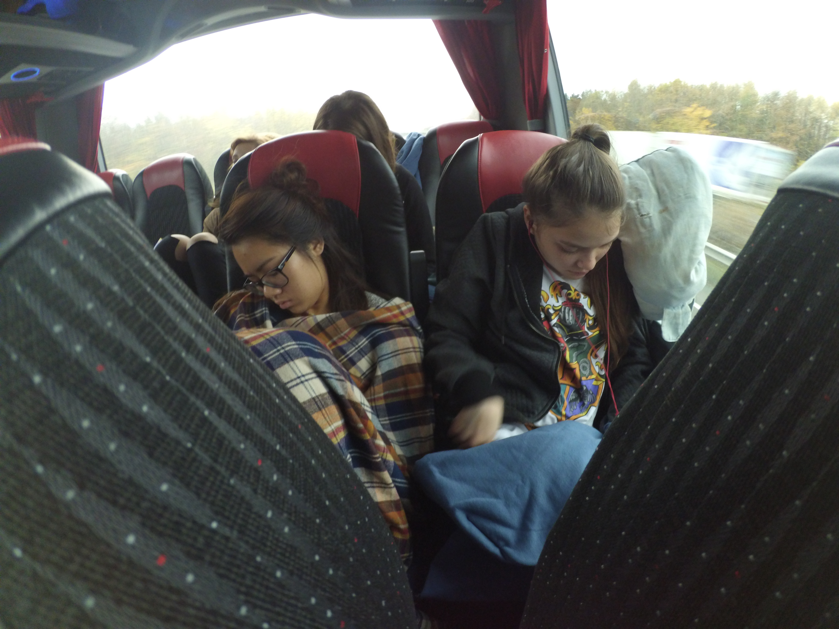

Early morning start – sleepy scientists

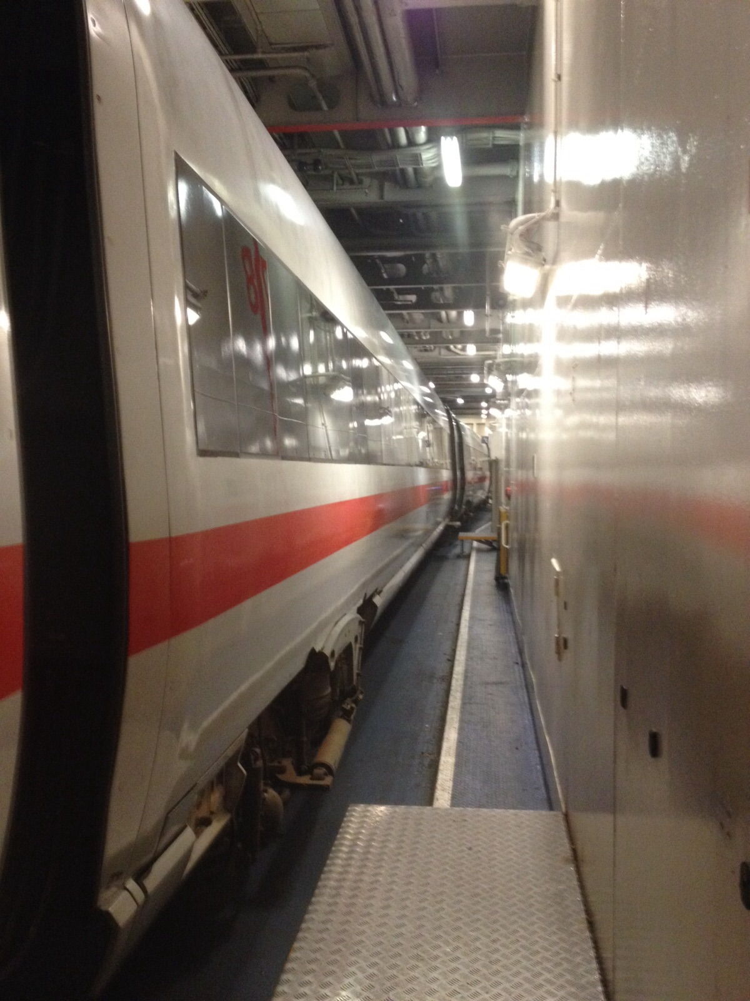

There was some ICE on the boat, which is something we hadn’t seen before.

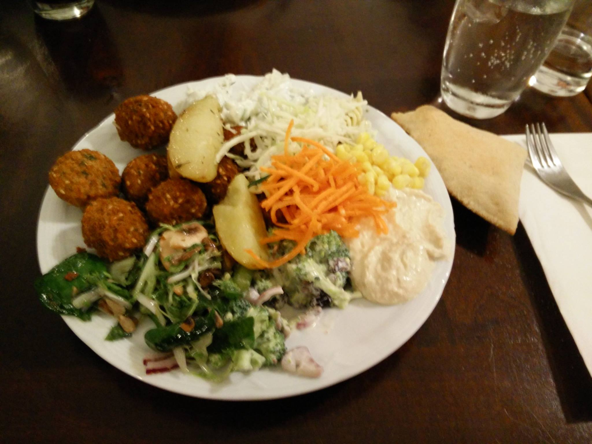

Never eaten so many veggies! There must be a mis-steak?!

Tuesday

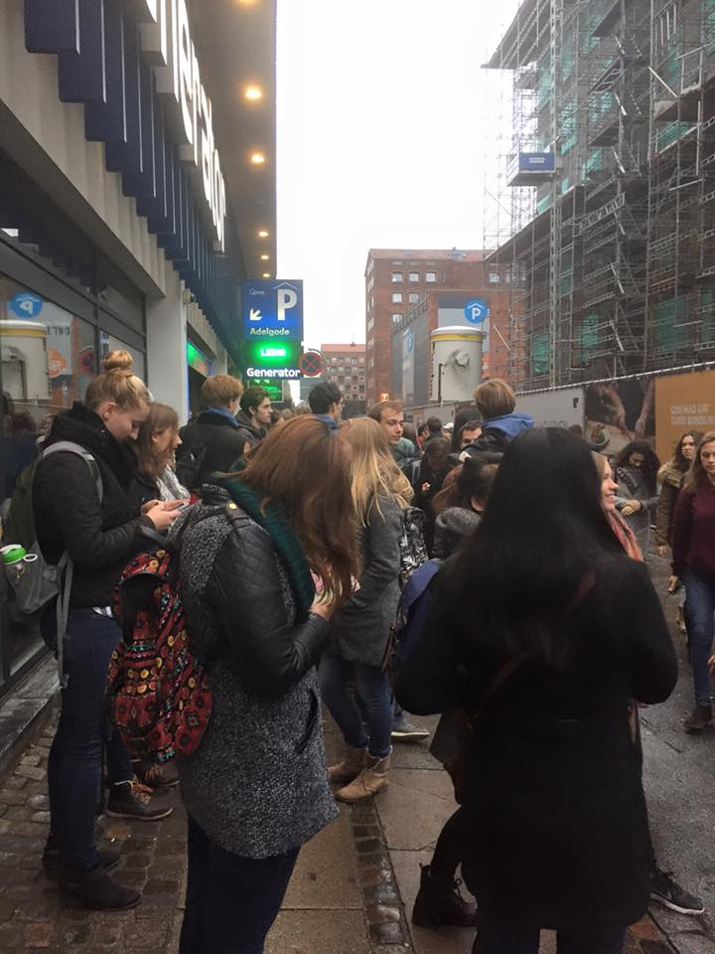

Gathering just outside of the Generator Hostel – we were actually fairly proficient at blocking roads.

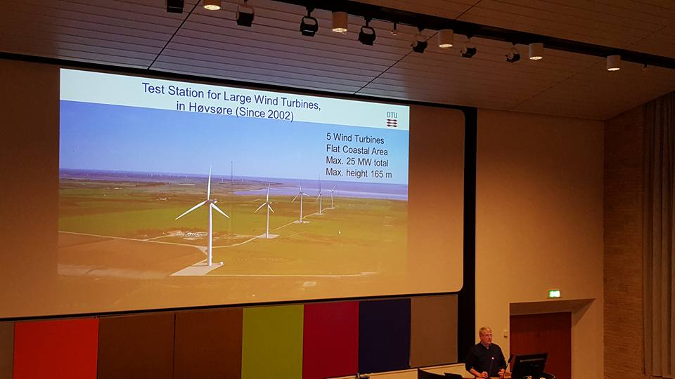

In Denmark a lot of research is being done into wind energy.

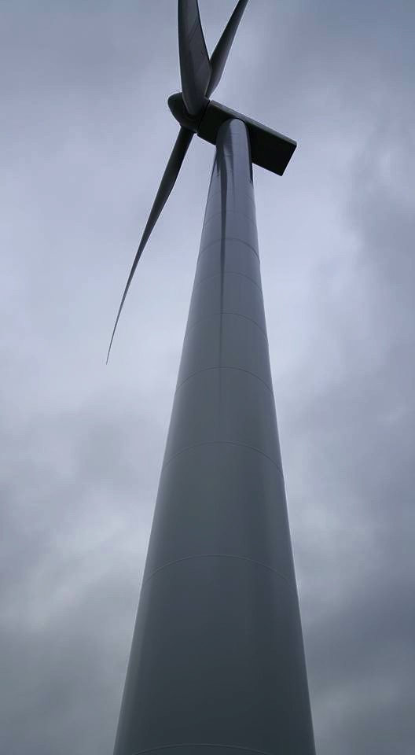

BIG LONG SHAFT – The largest is still thrice the size!

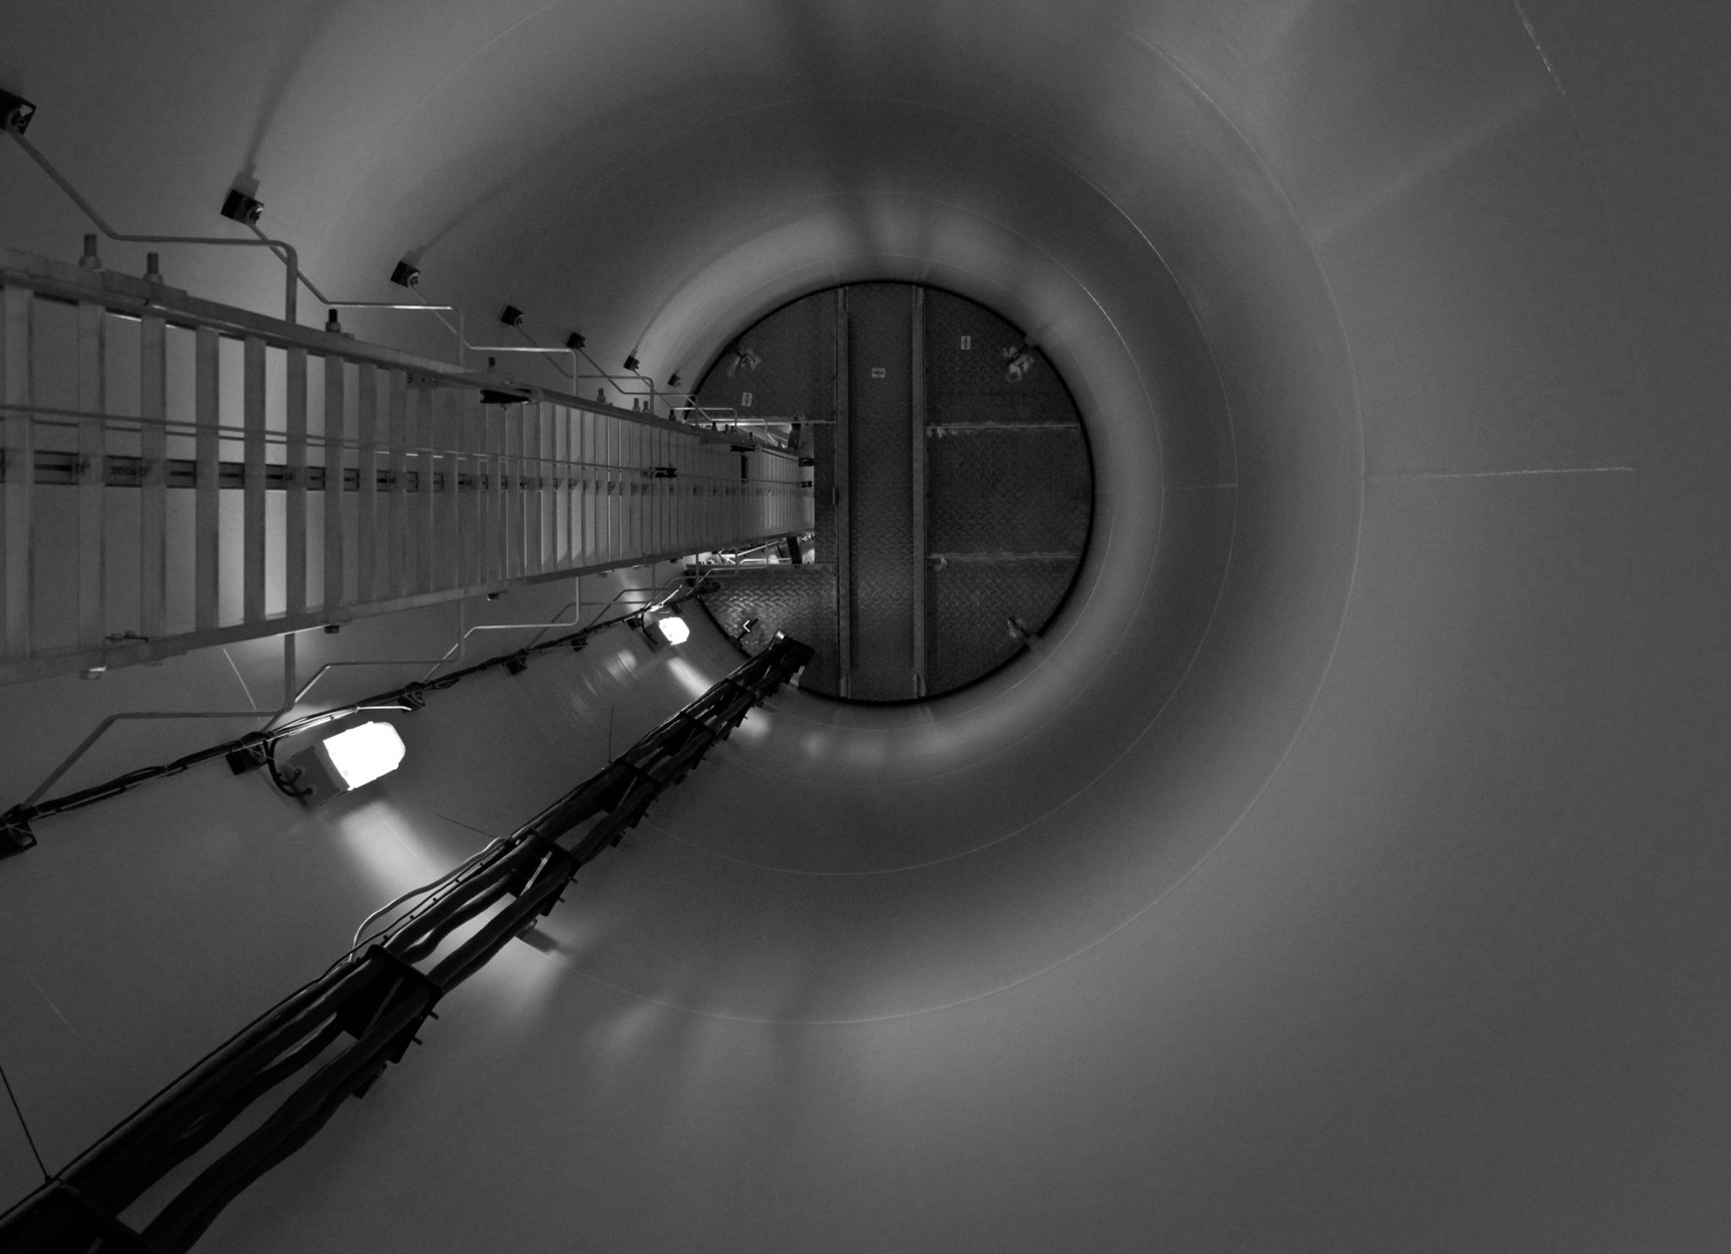

Inside the wind turbine – it was quite noisy and we couldn’t fit all at the same time.

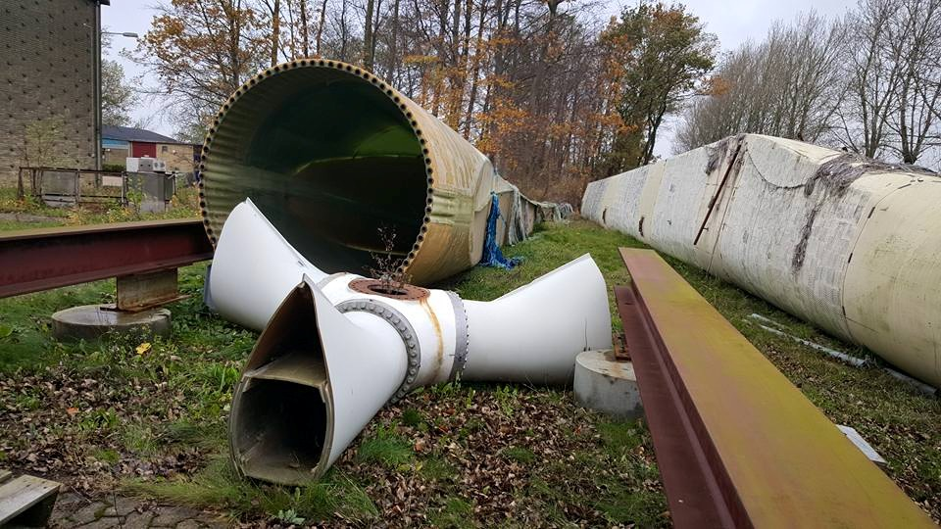

This is NOT Soviet Russia – these are various wind turbine parts!

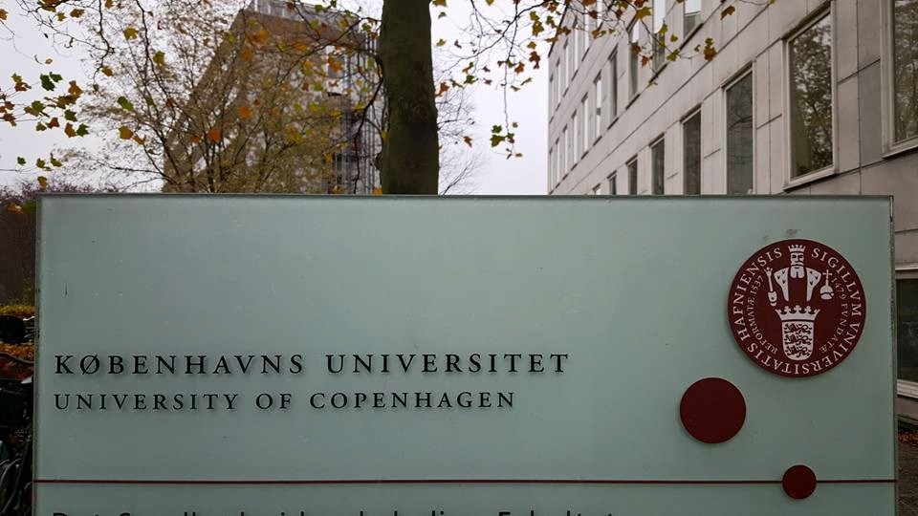

We ended the day at the University of Copenhagen – and again a lovely vegetarian dinner afterwards!

Wednesday

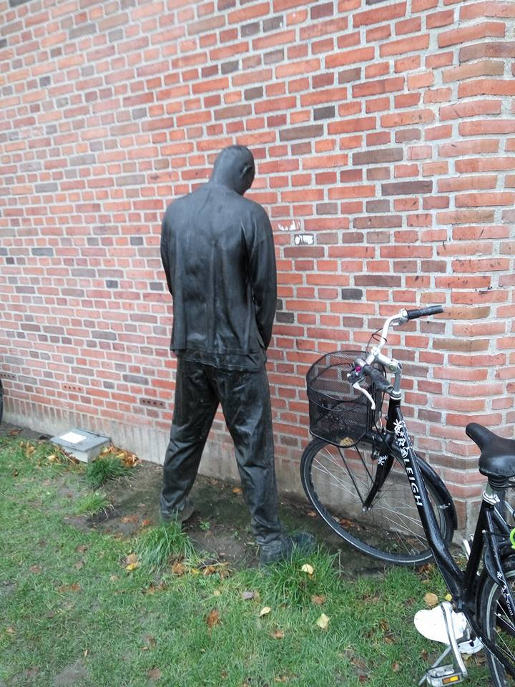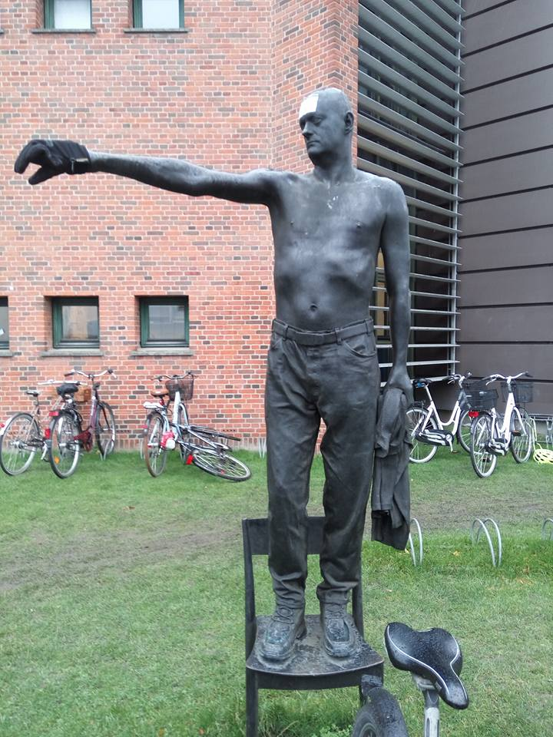

Some weirdly lifelike statues at the University – Copenhagen *really* likes statues. You’ll see…

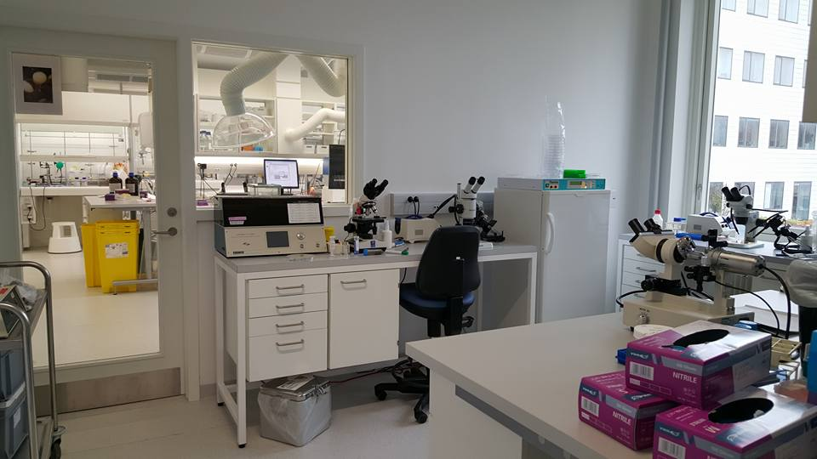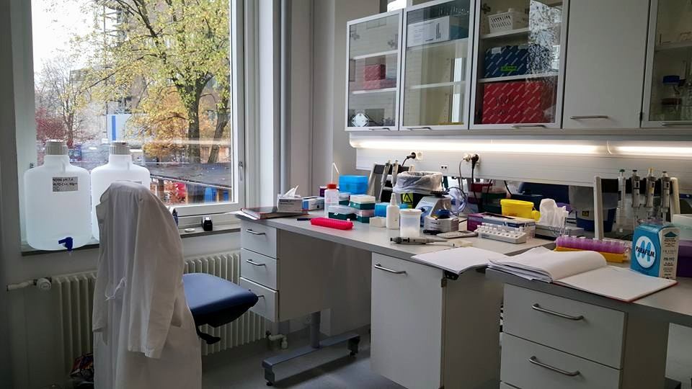 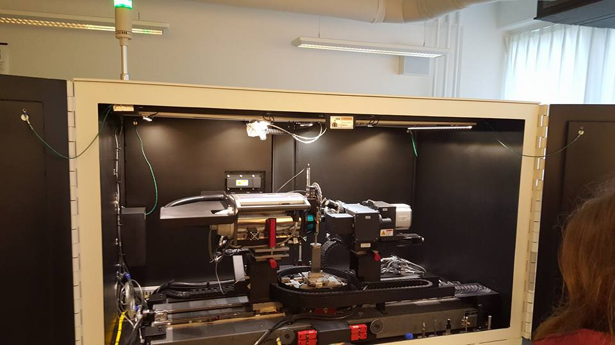

Some of the labs and lab equipment we got invited to take a look at. Looking at the price, the last of these three pictures might as well have been a Ferrari.

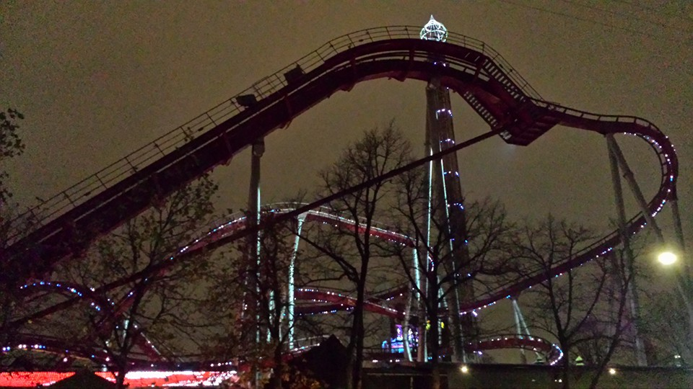

Tivoli by night – we passed the theme park on the way to bowling / swimming. Unfortunately it was closed during our visit ☹

Thursday morning

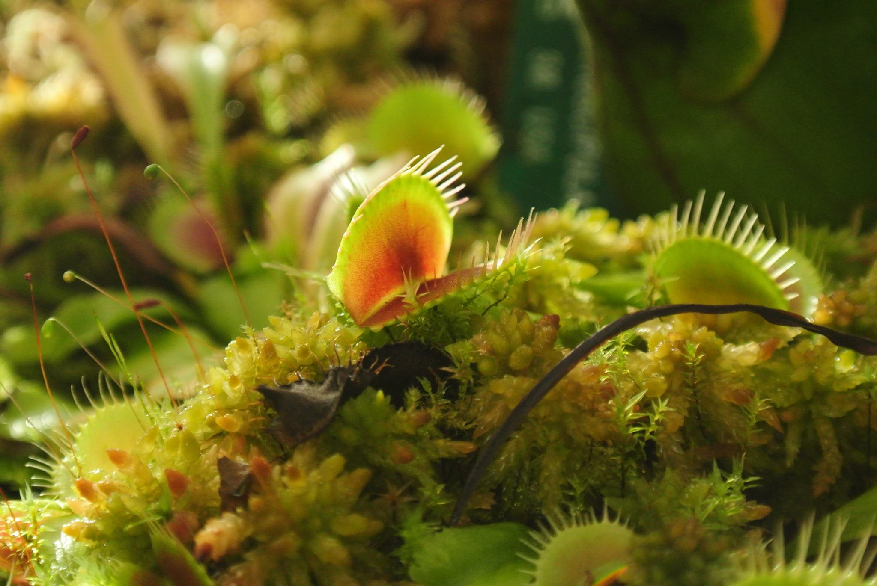

To the botanical gardens! The carnivorous Venus fly trap – luckily none of us were eaten.

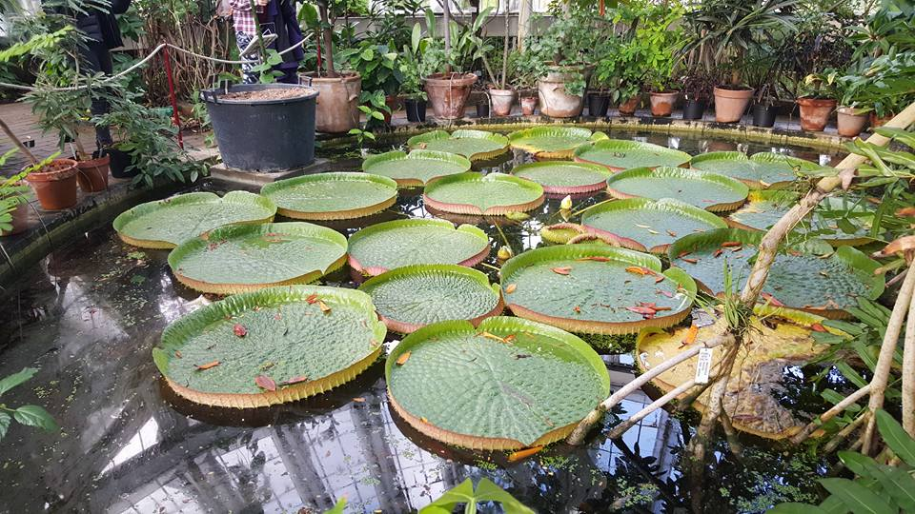

These lily-pads were HUGE! Everyone took a picture of these – rightly so.

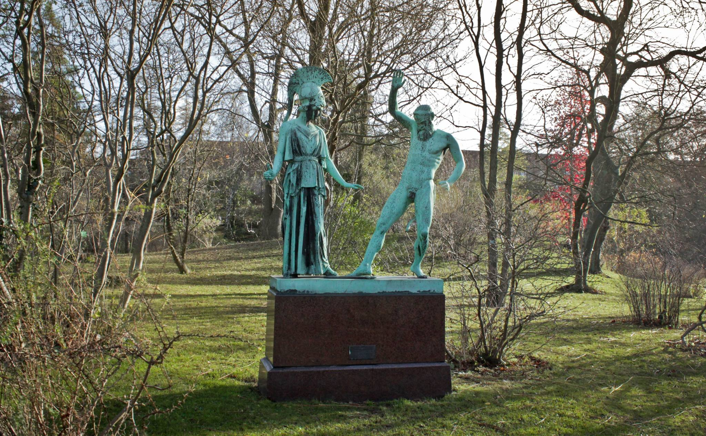

More statues – we’d like to think this one depicts the very first high-five.

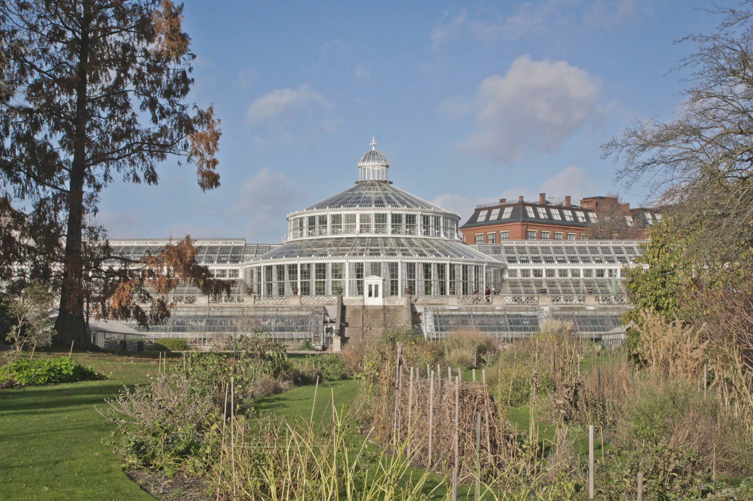

Stunning tropical greenhouse – it reaches up to 46 degrees inside in the summer!

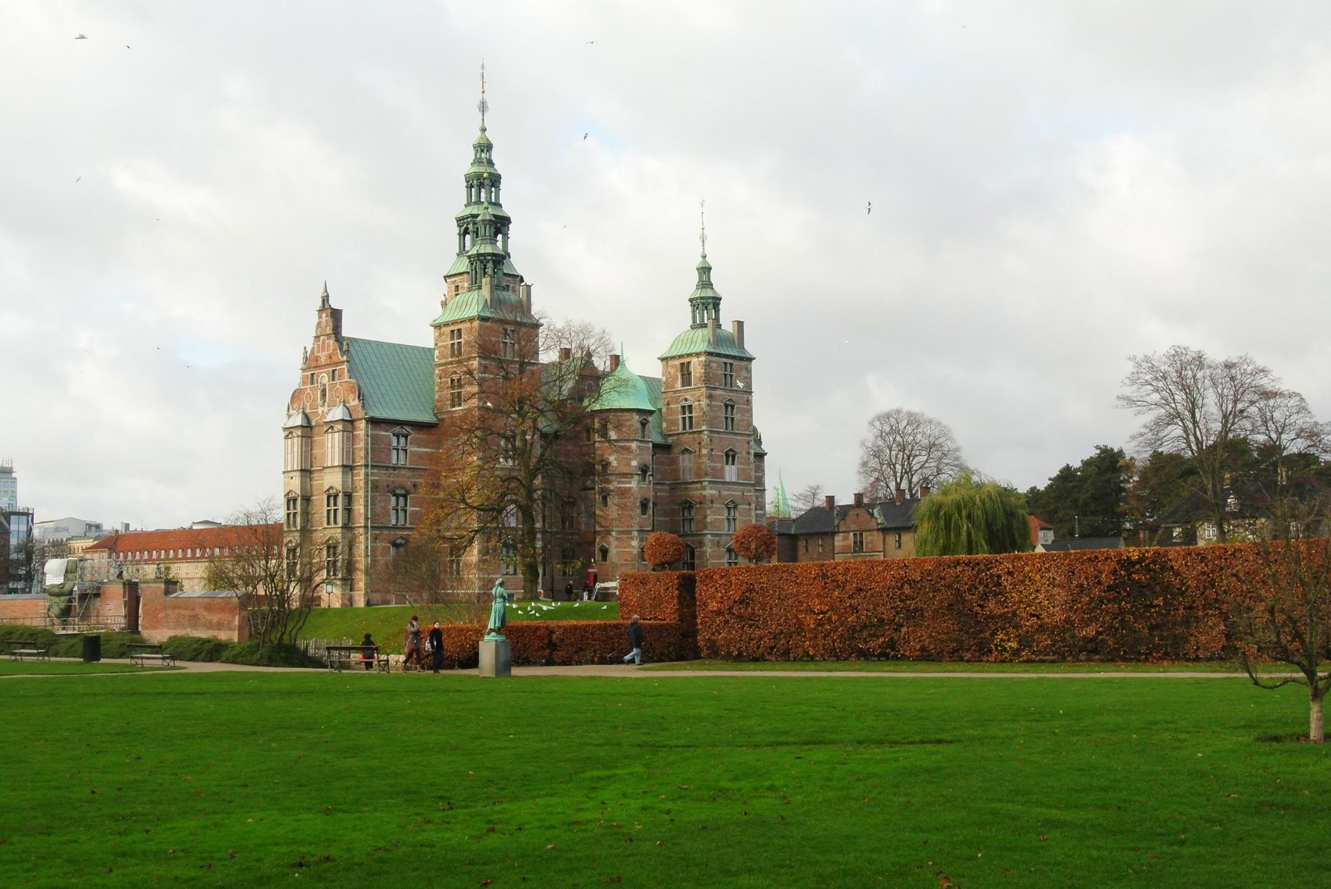

Typical historical Copenhagen architecture near the botanical gardens – we’d like to think this is the Royal Palace (but it’s not)

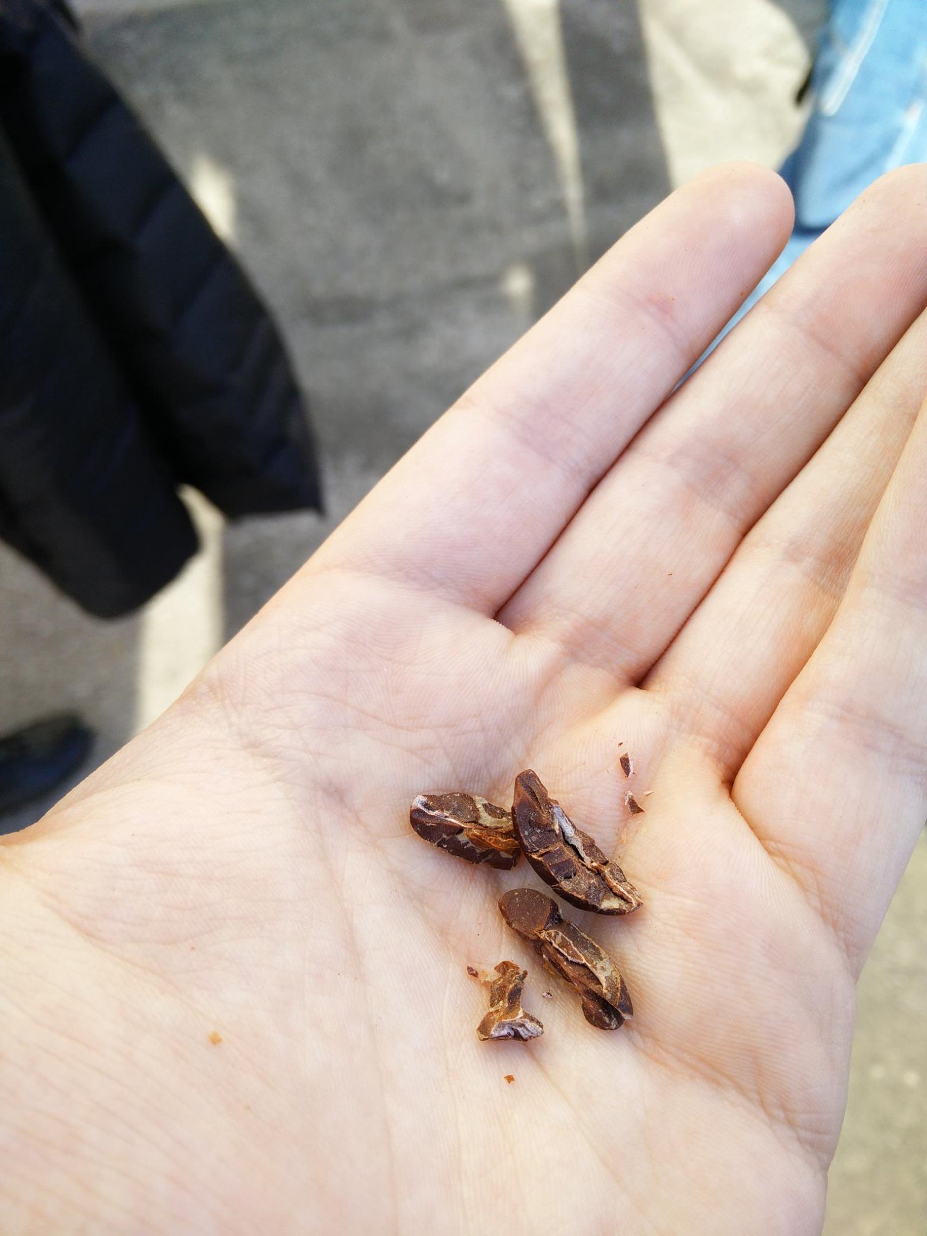

We got to try some cacao beans – they tasted great!

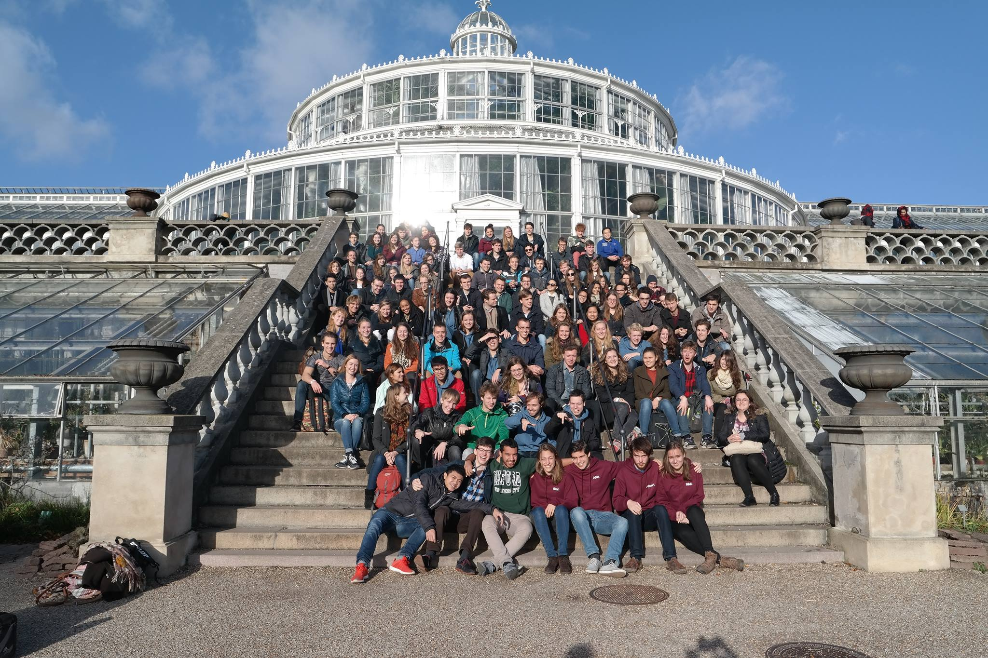

Of course, no trip is complete without a group picture – even though the trip hadn’t yet ended – we had a free afternoon to enjoy Copenhagen.

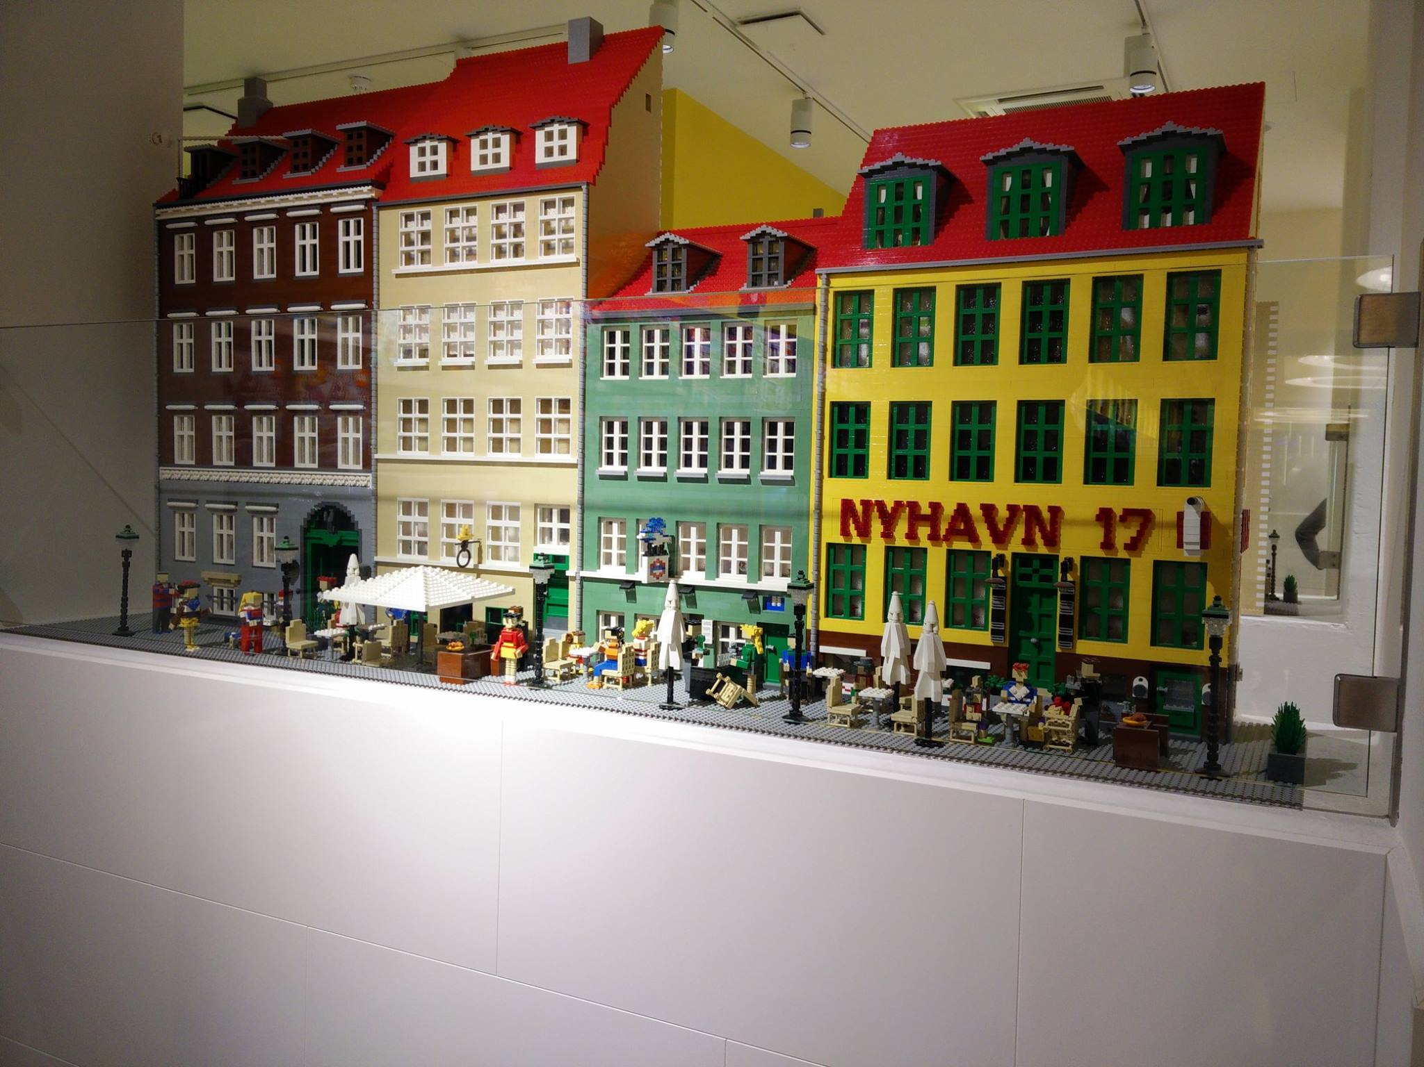FREE AFTERNOON

Probably the most famous sight in Copenhagen – the mermaid.

Then again, Nyhavn is another famous sight, and Lego quite likely Denmark’s most well-known product.

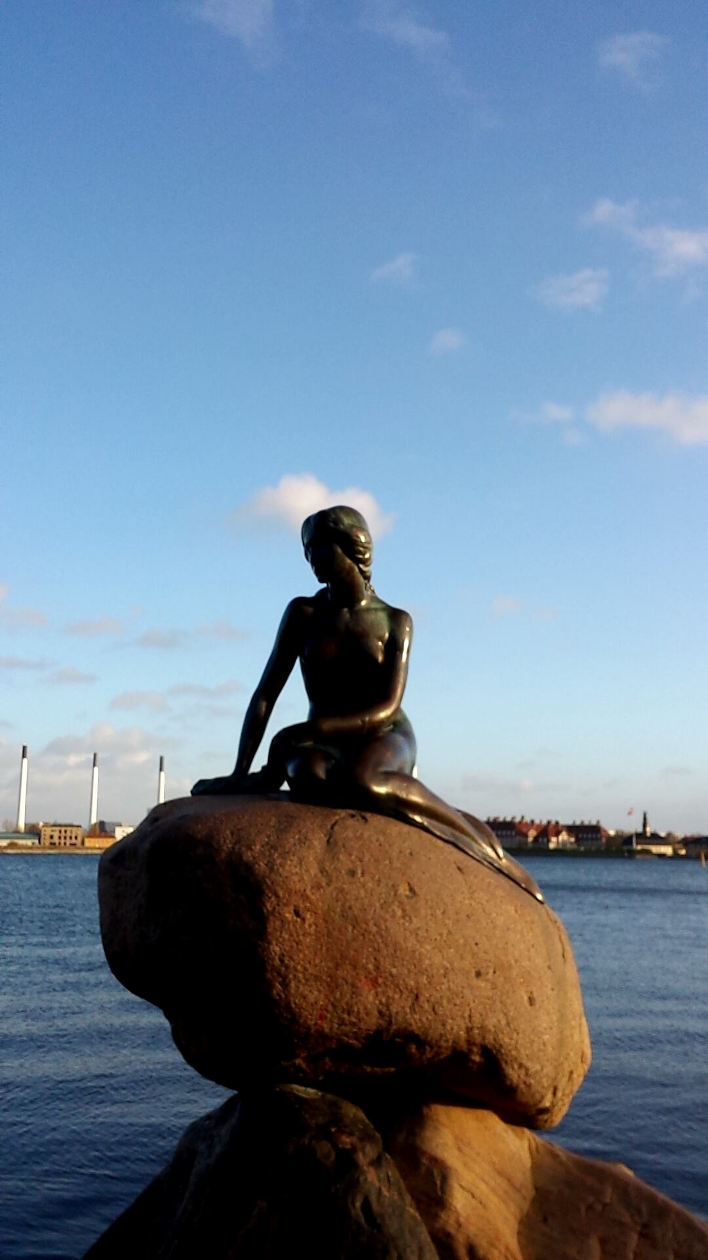

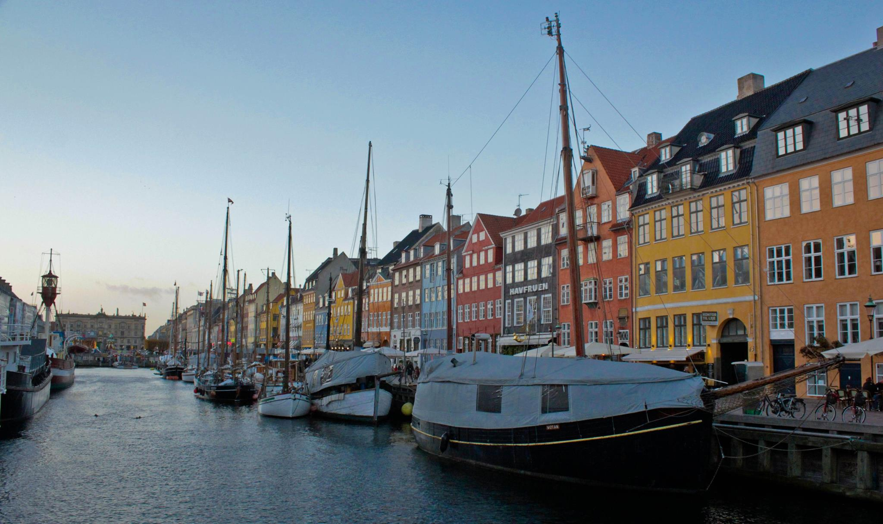

The actual real-life Nyhavn

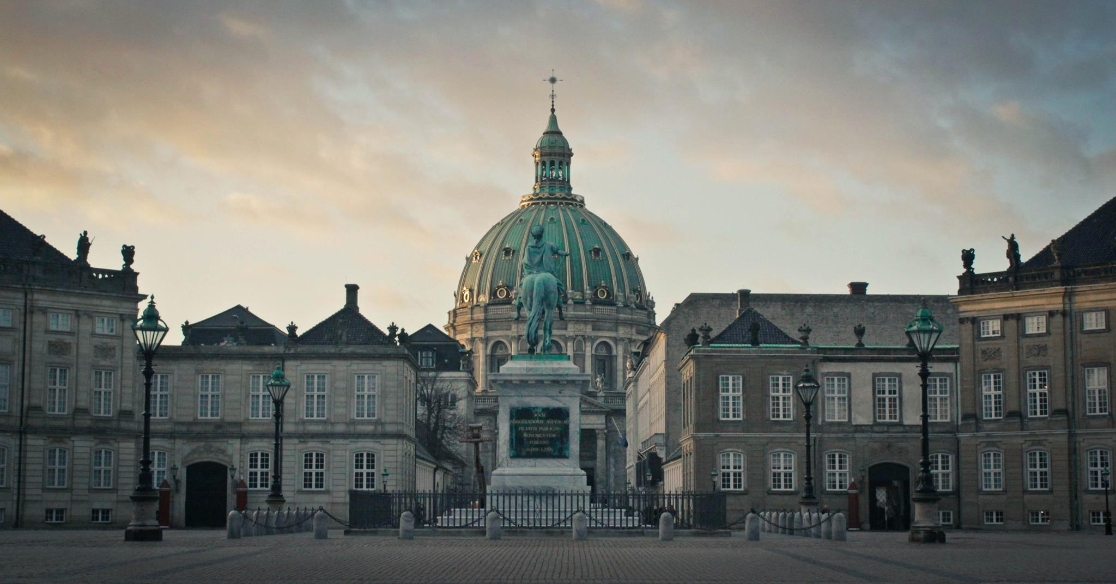

And another imposing example of Danish architecture and statues – don’t forget those.

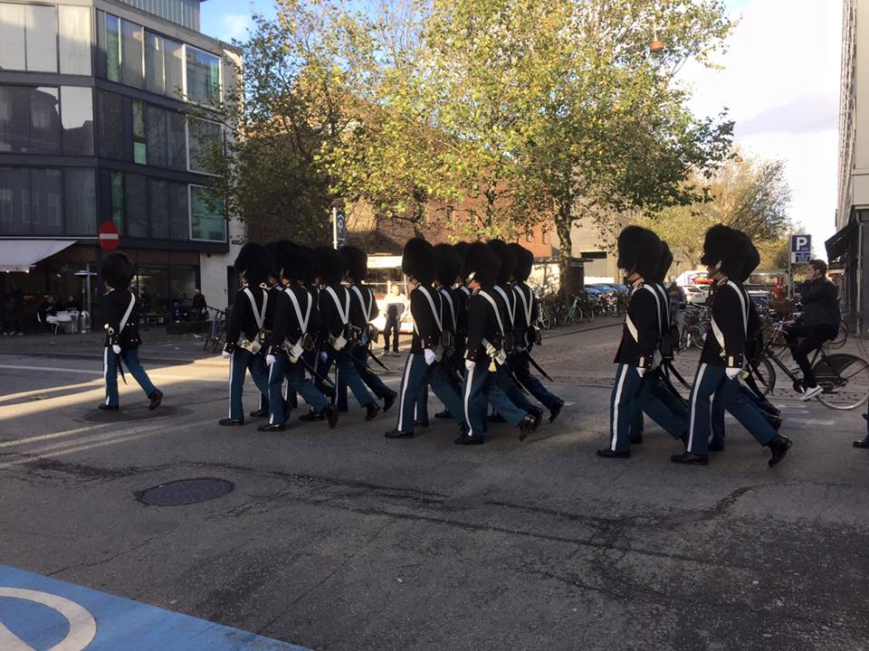

Lost on the way to Buckingham Palace – maybe we should’ve offered them a ride.

Alex Brown, Paul van Grol, Oscar Eijgenraam