Foto report of the 1st interdisciplinary honours symposium 2015-2016 “Natural sciences”
By Anne Snijders
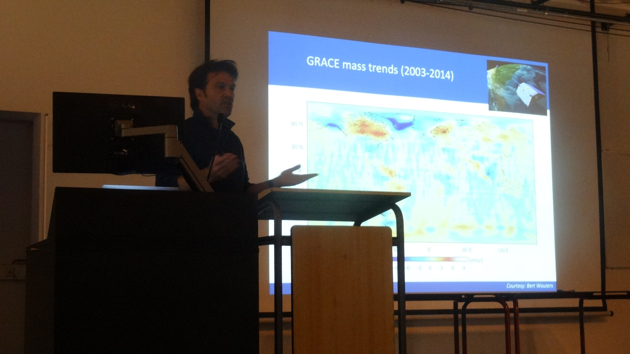
Michiel van den Broeke was the first speaker of the evening.

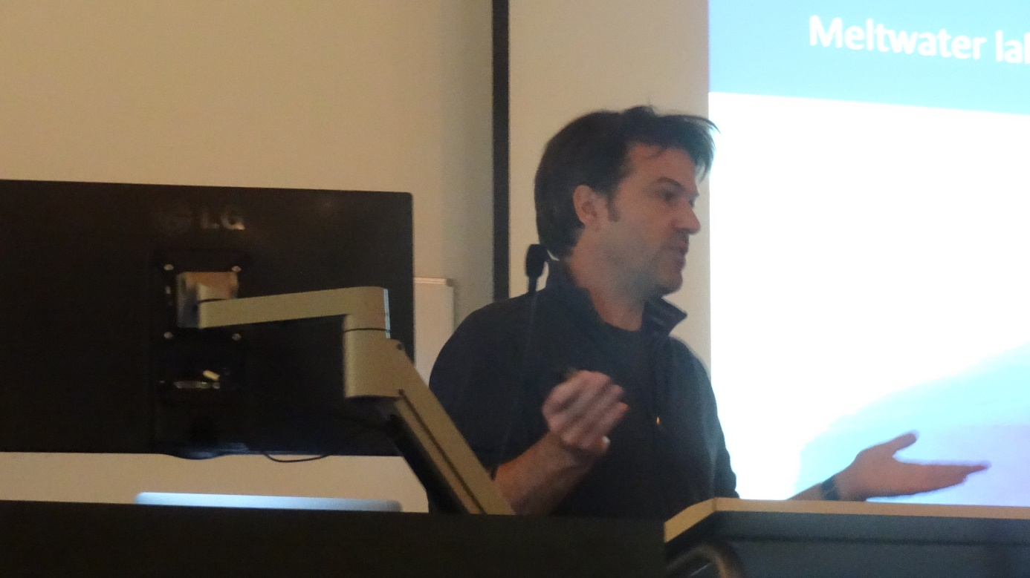
Michiel van den Broeke held an interesting talk about modelling the melting of the ice on Greenland.
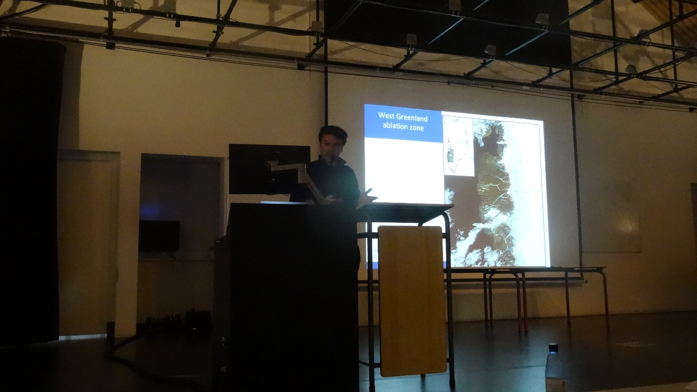
According to Michiel van den Broeke, the Greenland icecap measurements could be used to predict the future melting of the ice.
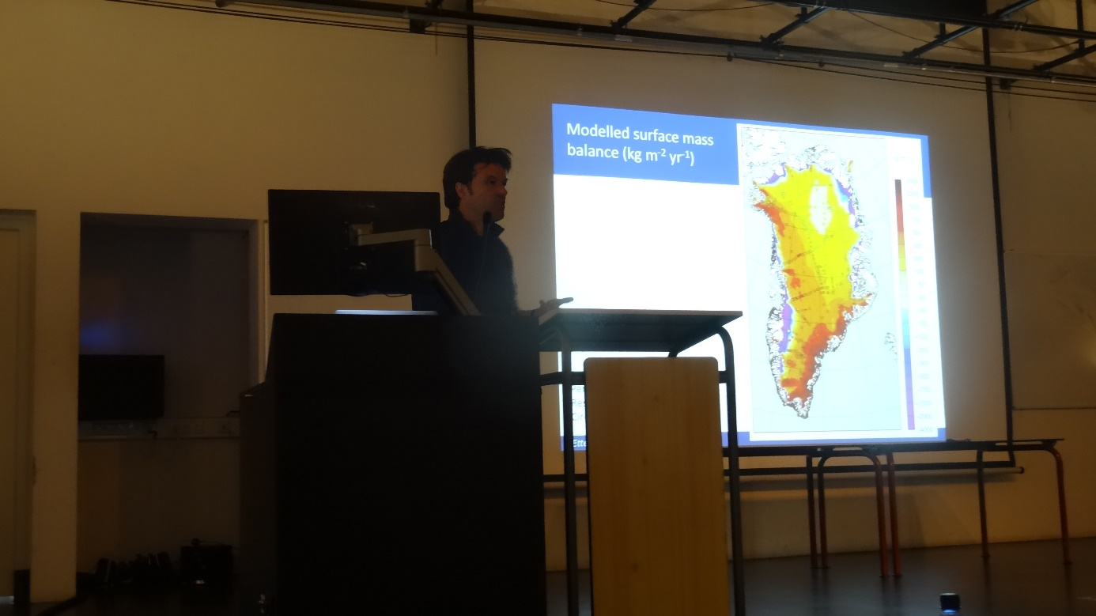
According to Michiel van den Broeke, the Greenland icecap measurements could be used to predict the future melting of the ice.
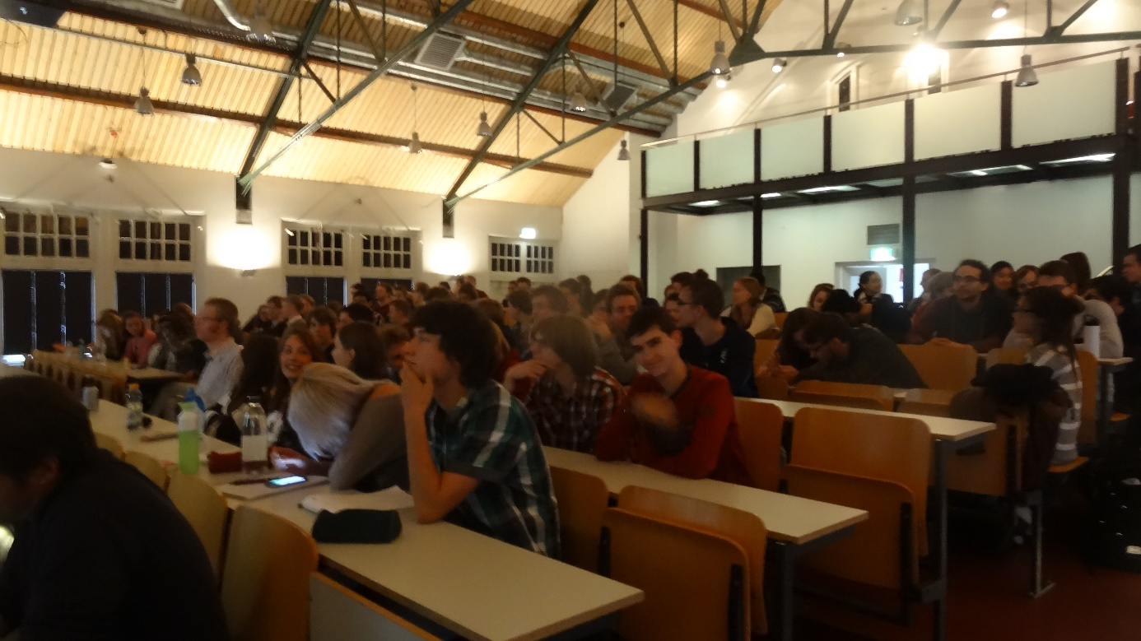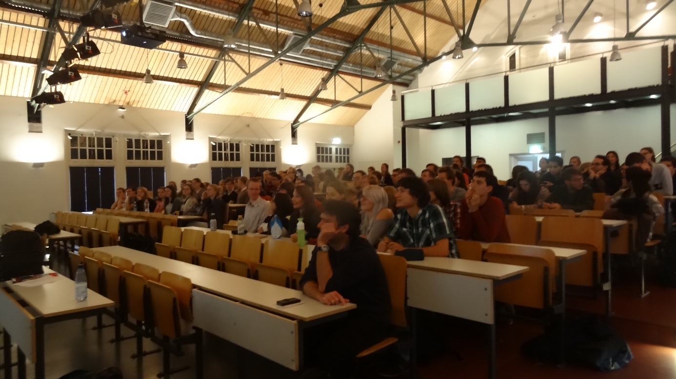
Even though the focus of the talks was physics and computer sciences. The different talks were interesting for a broader public of honours students.

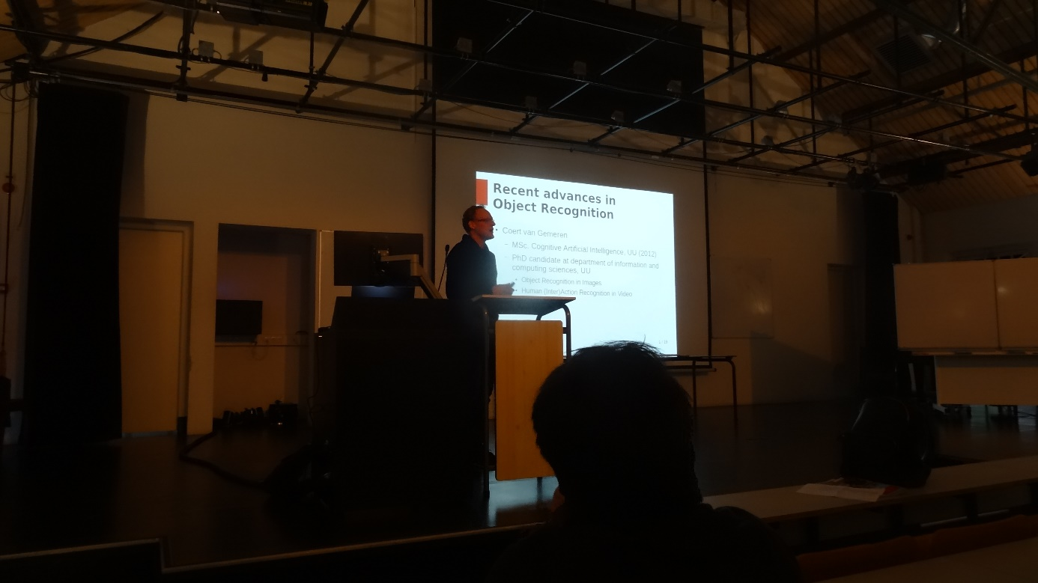
Coert van Gemeren was the second speaker of the evening.
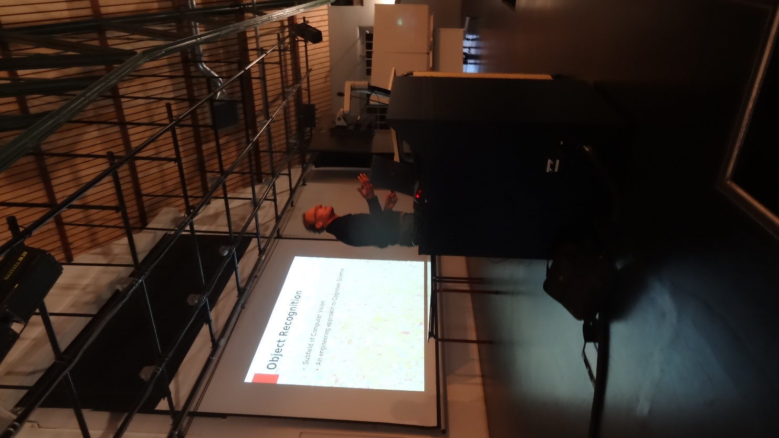
Coert van Gemeren talked about object recognition.
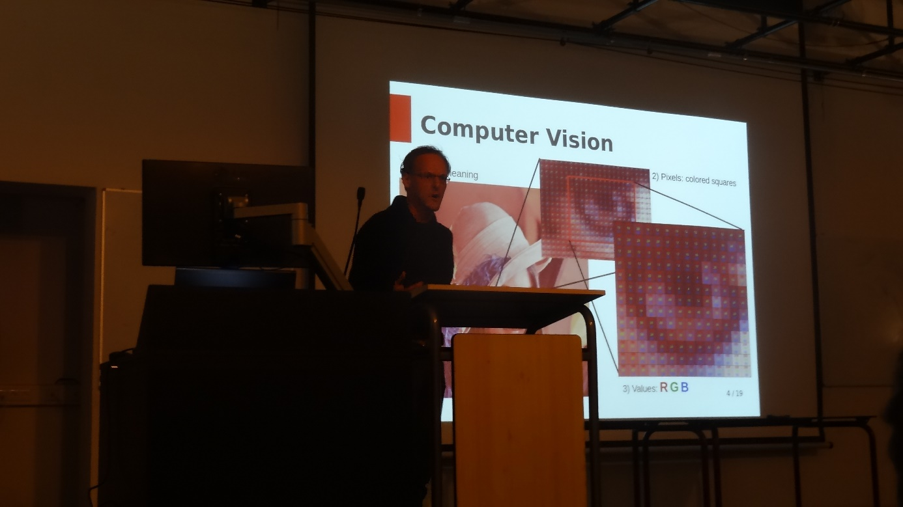
Computers can be teached to recognize objects within images.
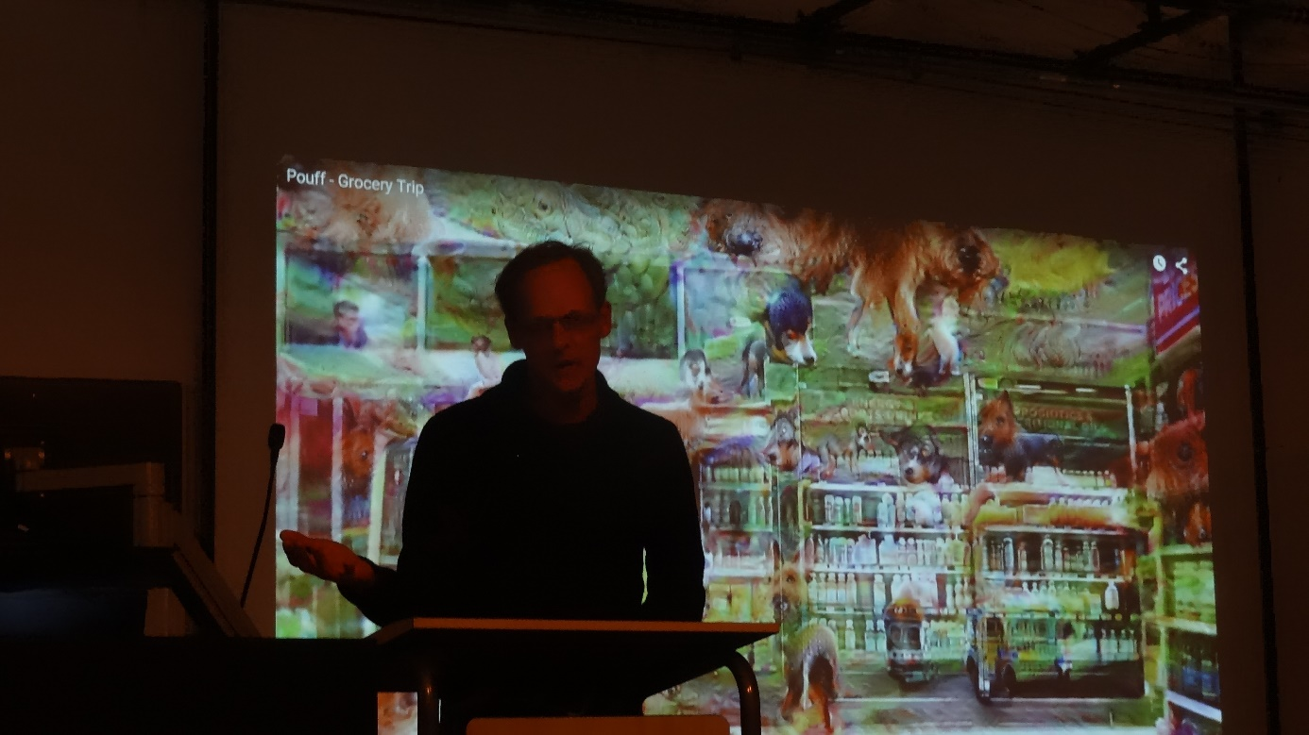
Even though it results in a colourful and inspiring video, this is still too complicated for moving (video) images.
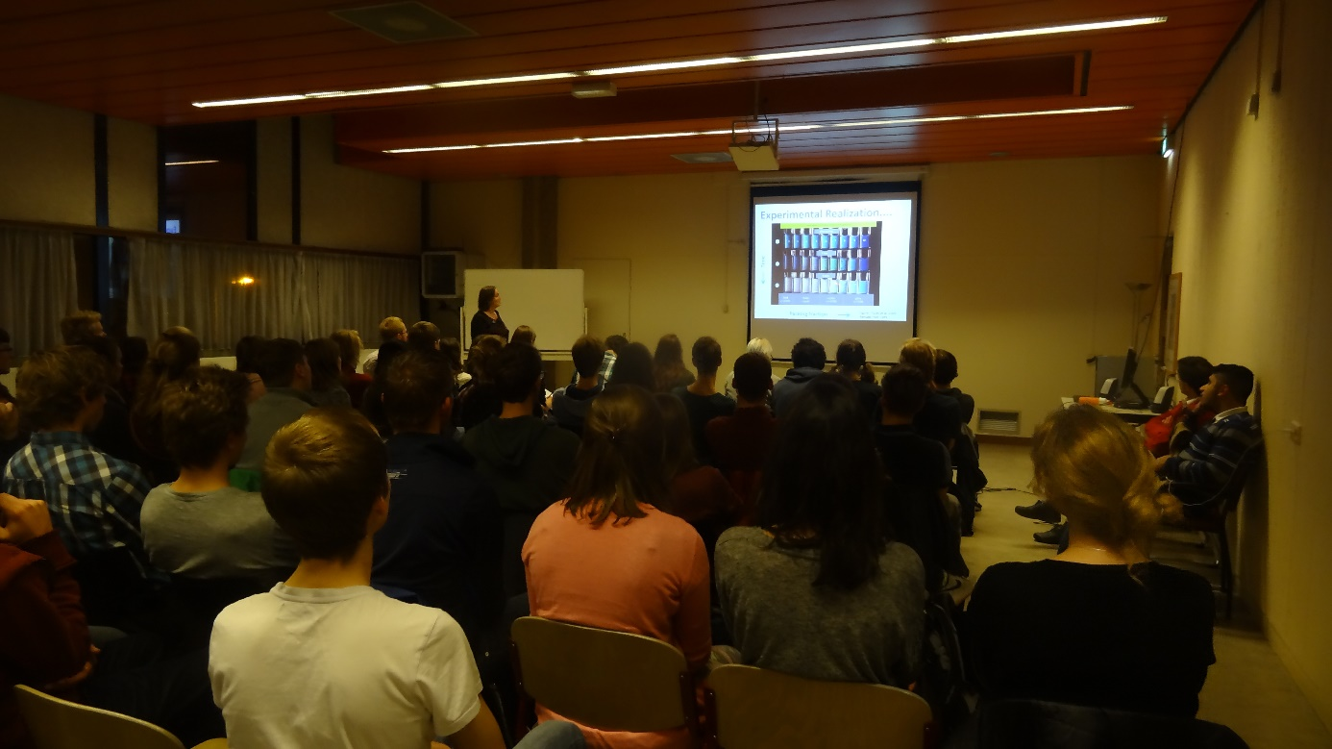
After dinner Laura Filion gave the last presentation of the evening.
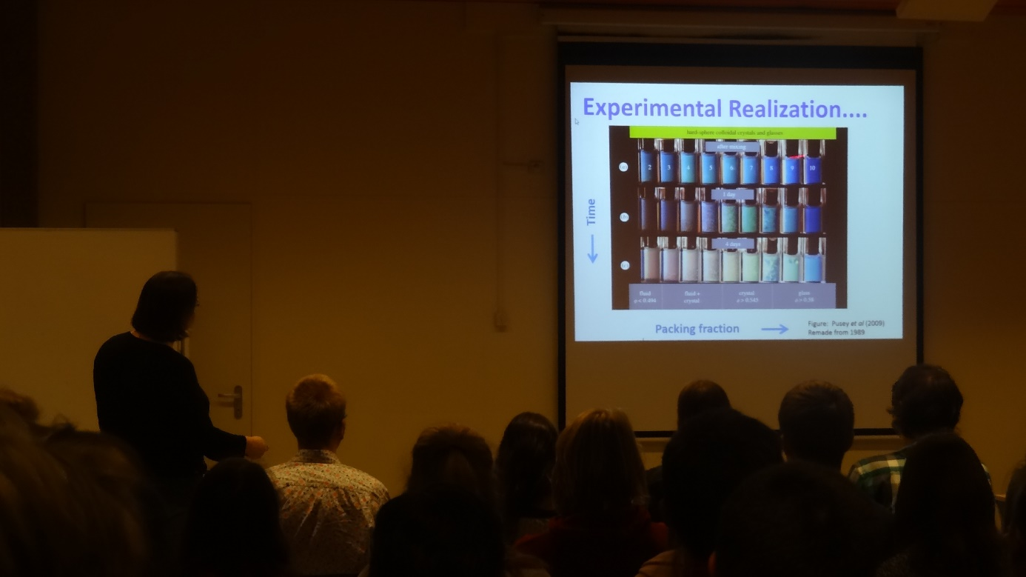
Laura Filion talked about hard sphere nucleation and what is known about this phenomenon.
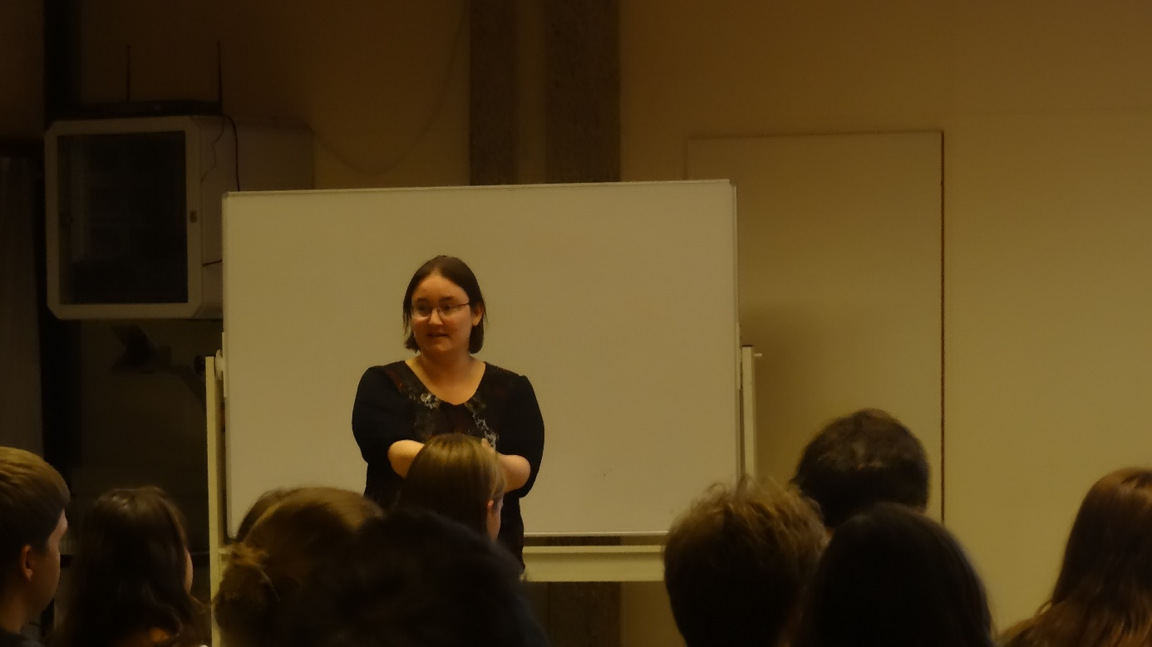
Even though we had to change to a different location just before the talk of Laura Filion, it was a nice evening filled with interesting talks.

